
Report

Team ID | MCA
Project Name | Smartphone Addiction & Digital Well-Being Insights
Maximum Marks | 5 Marks

A project report acts as an organized technical framework designed to deliver detailed dataset findings, empirical evidence, and behavioral insights. This documentation provides stakeholders, design engineers, and wellness panels with a structural understanding of passive telemetry data patterns.
Structuring analytical records inside reporting platforms relies on configuring database pipelines, arranging chart canvases logically, and ensuring clean theme uniformity. The main goal is to optimize information delivery, helping research teams iterate on dashboard components to improve the clarity of behavioral tracking.

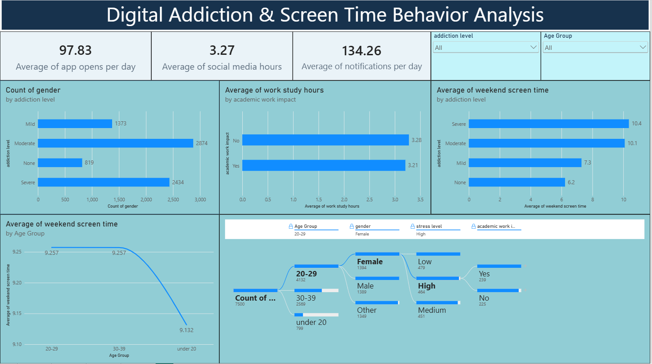
Observational trends derived from analytical metrics provide teams with strategic focus parameters and diagnostic markers:
- Trends Over Time:
- Severe classification categories dominate the tracking pool, with high-risk dependency segments heavily outnumbering initial non-addicted or mild groups. This indicates a high concentration of profiles shifting toward maximum risk boundaries.
- Weekend device interaction trends climb steeply across advanced dependency profiles. These users demonstrate a massive expansion in weekend phone use compared to lower risk tiers, revealing a sharp usage gap between tracking groups.
2. Performance Comparisons:
- Productivity and academic outputs behave independently of baseline task time allocations. Monitored focus hours show nearly identical distributions regardless of reported professional friction, suggesting device checking breaks work focus through disruption loops rather than simple time theft.
- High engagement maps as the baseline pattern for the population. A dominant majority of active channels fall squarely into elevated consumption tiers, confirming that extensive phone use is common across the entire tracked cohort..
3. Customer Segmentation:
- Unstructured weekend use decays predictably across age milestones. The data shows that weekend phone engagement reaches its absolute peak during the 20–29 young adult bracket, followed by a steady decrease across the 30–39 career tier and under-20 student clusters.
- Sleep duration shows a gradual downward trend as age increases. While younger segments maintain slightly higher baseline rest windows, the average rest window falls below recommended benchmarks for the primary 20–29 tier, pointing to poor late-night digital hygiene habits.
- Interaction metrics show equal distribution across subjective user states. Baseline metrics for low, medium, and high stress remain statistically flat across the dataset, proving that device dependency occurs uniformly across all emotional profiles.
4. Goal Achievement:
- Social application consumption climbs in sync with higher addiction levels. Users in advanced classification brackets allocate significantly more time to social platforms than to work tasks, making social media time a strong indicator of device addiction.
- Total screen time remains the single most accurate predictor of user dependency. Key driver modules confirm that a high baseline of daily screen exposure acts as the primary indicator of addiction, outweighing other behavioral variables.
- The cohort displays high baseline interaction rates, averaging 97.83 daily application openings alongside 134.26 incoming notification alerts. This continuous pairing points to a highly reactive, distracted device use habit loop across the network.
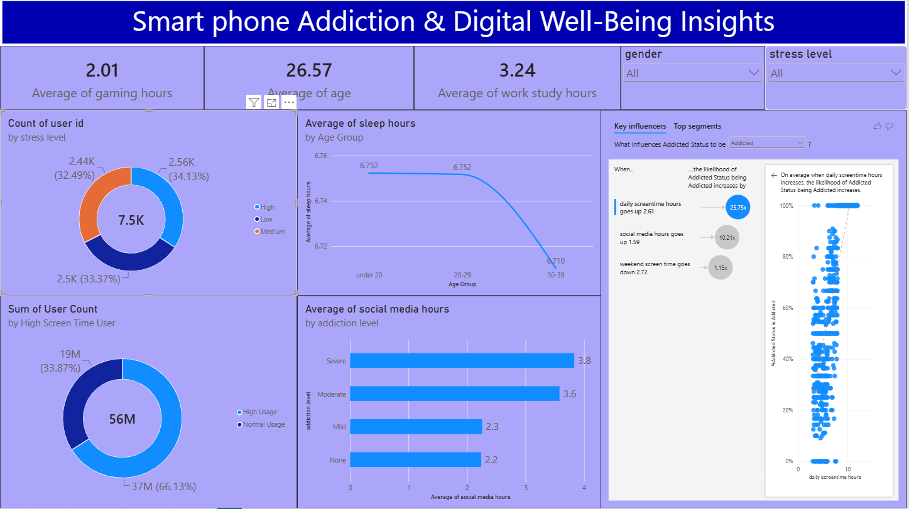
Example:
1. Addiction Severity
A substantial portion of the user base is clustered within advanced dependency brackets. These high-risk user segments demand far greater weekend screen availability and active device access compared to baseline non-addicted control groups.
2. Age, Sleep and Weekend Usage
Weekend mobile exposure maps changes across specific age cohorts, with the 20–29 age bracket registering the highest weekend screen expansion. Biological sleep metrics display a matching variation across different age tiers.
3. Engagement and Usage
A major segment of the monitored pool falls under elevated daily use categories. Users average 97.83 manual application opens and 134.26 notification tokens every 24 hours, paired with a high daily investment in social media platforms.
4. Stress and Academic/Work Impact
Monitored stress levels show a balanced, uniform distribution across the high, medium, and low classification cohorts. Overall task productivity averages approximately 3.3 hours for profiles logging negative academic impacts, mirroring the metrics tracked for impacted professionals.

